
ASSIGNMENT 2.3

Htno : 2303A51584
Batch – 05

Task – 01
Prompt :Write a Python script to analyze a log file and count keyword frequency.
Code :
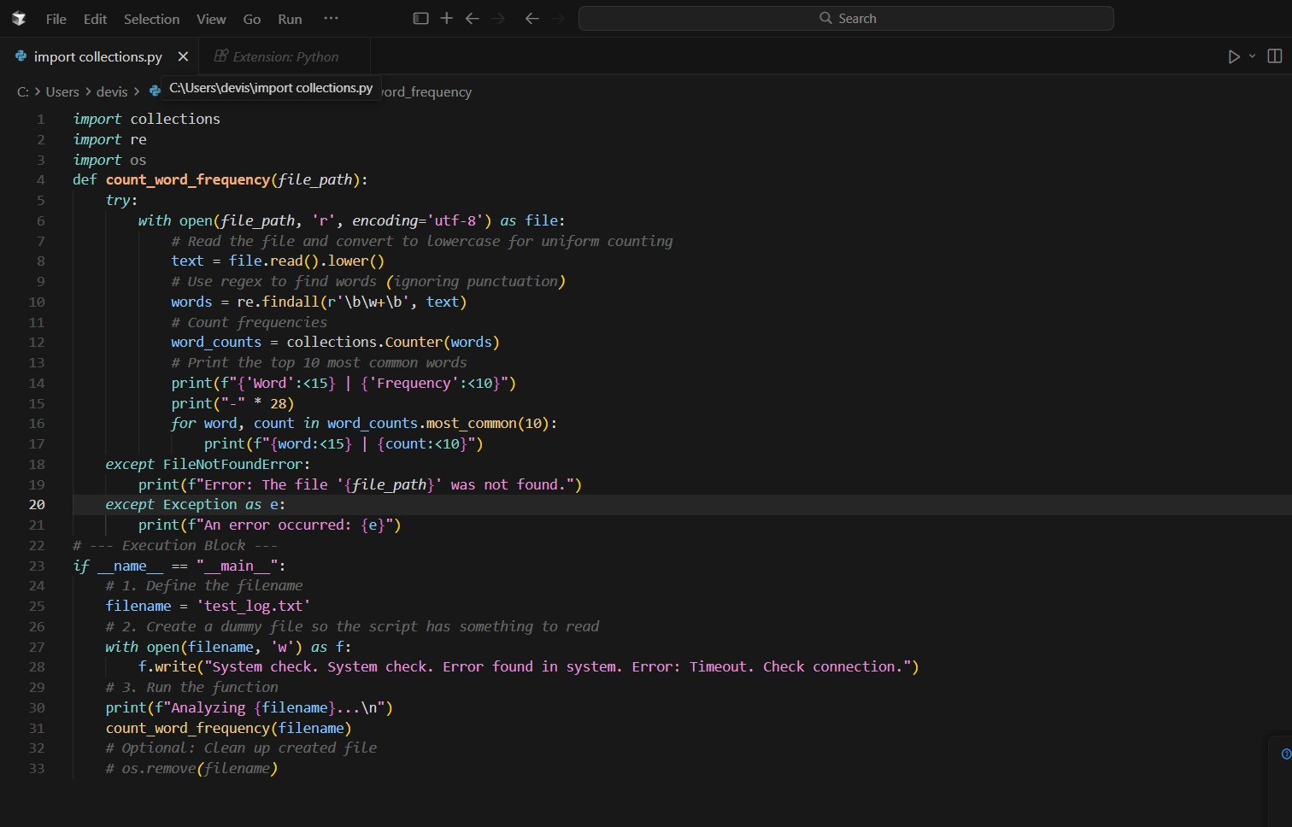
Output :
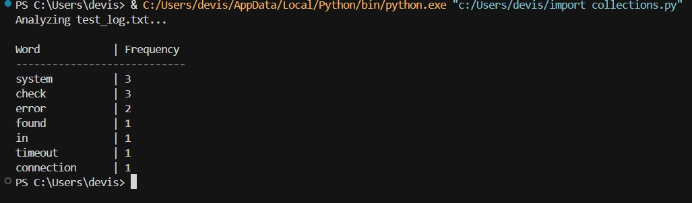
Explanation :
- Imports libraries for word counting (Counter), pattern matching (re), and file handling (os).
- Reads a text file and converts all text to lowercase.
- Uses regex to extract words while ignoring punctuation.
- Counts how many times each word appears.
- Displays the top 10 most frequent words in table format.
- Uses try-except to handle missing files or runtime errors.
- Creates a sample file for testing the function.
- Calls the function to analyze the file content.
- Optional line can delete the test file after execution.

TASK – 02
Prompt :Write a Python program that creates a text file, writes sample text into it, then reads and prints the file content.

Code :
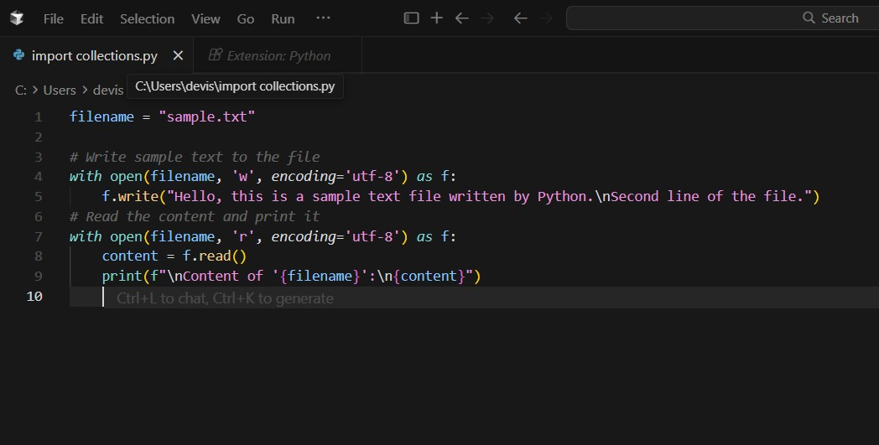

Output :
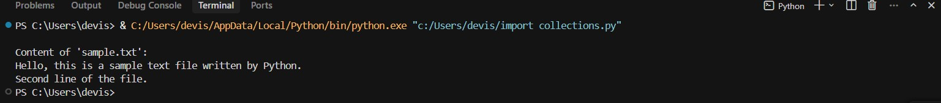
Explanation :
- Stores the file name in a variable.
- Opens the file in write mode and writes sample text into it.
- Automatically closes the file after writing.
- Reopens the file in read mode.
- Reads the entire content and prints it to the screen.

Task – 03
Prompt :Write Python code to read a CSV file using pandas and calculate the mean, minimum, and maximum of a numeric column.
Code :
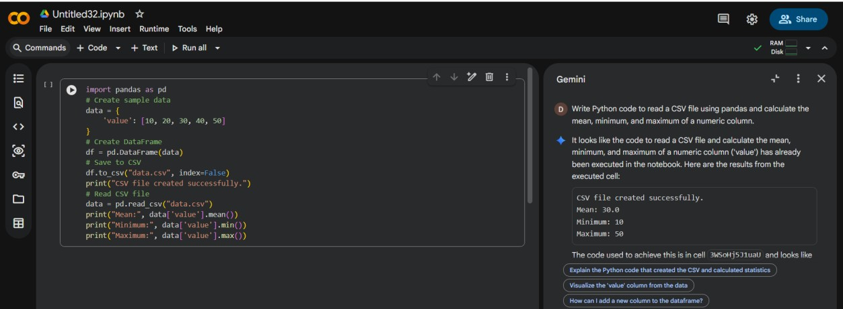
Output :
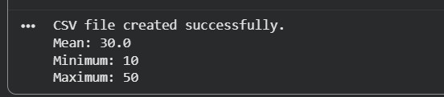
Explanation :
- Imports the pandas library for data handling.
- Creates sample numeric data in a dictionary.
- Converts the data into a DataFrame.
- Saves the DataFrame as a CSV file.
- Reads the CSV file back into the program.
- Calculates and prints the mean, minimum, and maximum values.
TASK – 04
Prompt :Write Python code for Bubble Sort and Python’s built-in sort() method, then give a short comparison of both in terms of efficiency and simplicity.
Code :
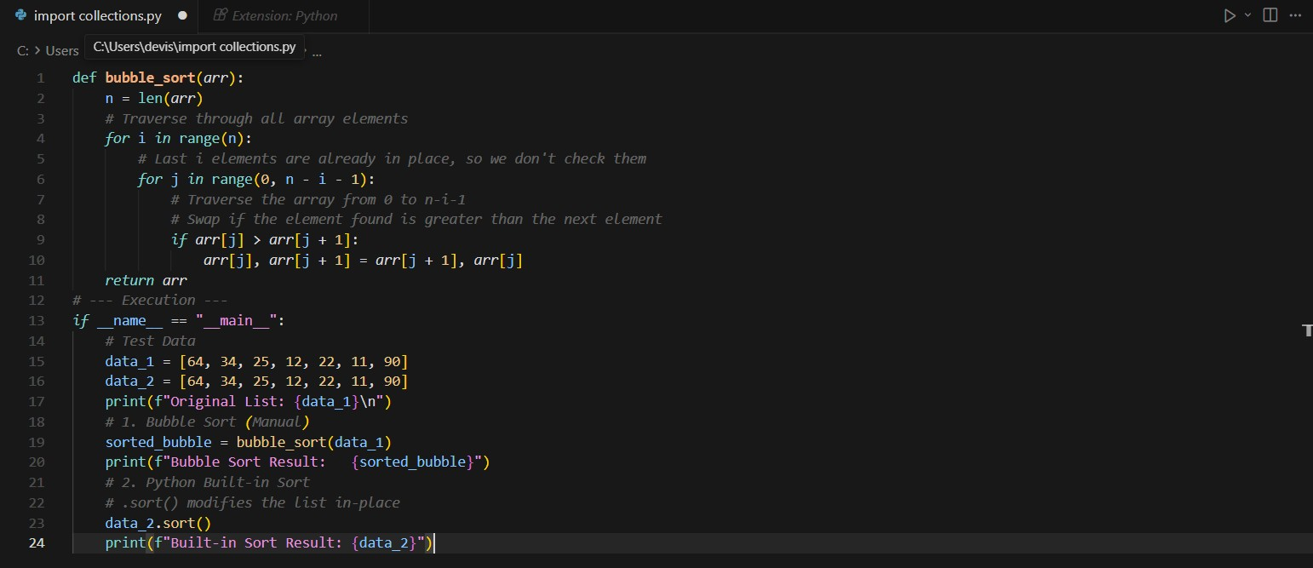
Output :
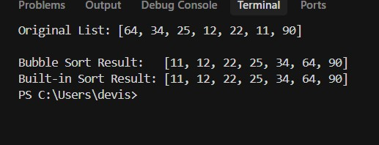
Explanation :
- Bubble Sort is a manual sorting algorithm that repeatedly swaps adjacent elements, it is easy to understand but slow for large lists.
- Built-in sort() is optimized and much faster because it uses Python’s efficient internal algorithm.
- Bubble Sort has higher time complexity (O(n²)), while built-in sort is more efficient (≈ O(n log n)).
- Built-in sort() is preferred in real applications due to better performance and simplicity.

